Subrede: 192.168.0.0

Mascara de subrede: 255.255.255.0

BroadCast: 192.168.0.255

QI-01



IP: 192.168.0.1

MS: 255.255.255.0

GP: 192.168.0.254

DNS P: 192.168.0.254

DNS A: 8.8.8.8

QI-03

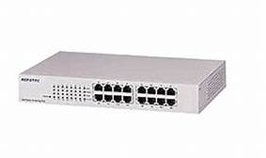

10.1.1.1

45.5.211.10

192.168.0.254

10.1.1.10

Grupo de trabalho

QI

QI-04

QI-02

IP: 192.168.0.2

MS: 255.255.255.0

GP: 192.168.0.254

DNS P: 8.8.8.8

DNS A: 8.8.4.4

IP: 192.168.0.4

MS: 255.255.255.0

GP: 192.168.0.254

DNS P: 8.8.8.8

DNS A: 8.8.4.4

IP: 192.168.0.3

MS: 255.255.255.0

GP: 192.168.0.254

DNS P: 8.8.8.8

DNS A: 8.8.4.4